**Task Document and testing process**

**Date- 07-06-2020**

**@author sarlesh**

**\* This document for upload project to server and test by each and every url given below.**

**Important points-**

1. **All task code and files store in sarlesh folder . if you are uploading on server then direct upload folder.**
2. **For Database “test” sarlesh/database/test.sql**
3. **For authentication of API used “basic auth”**

**Username- “admin”**

**Password- “1234”**

1. **Technology- for demo purpose used Codeigniter And Angular js and mysql.**

**For realtime and secure project I will be prefer “LarAvel with oAuth 2 and angular and postgres ”.**

**1-Using any MVC Framework or with oops concept create the web apps with following details**

**a- provide a view interface to make an ajax based requests with any required filter.**

**b- provide the following operations for managing the router details**

**i- CREATE**

**ii- UPDATE**

**iii- SOFT DELETE**

**IV- PAGINATIONS**

**c- following are the network router details**

**I- DNS records**

**II- internet host name**

**III- client ip address**

**IV- MAC address**

**Answer- for This task I preferred Angular js . I have created APIs with basic auth and call these apis through angular js , and form UI used bootstrap and data table**

**URL-** [http://127.0.0.1/sarlesh/#/routers](http://127.0.0.1/sarlesh/" \l "/routers)

O/P- screens given below

1. Data table page with sorting searching and pagination

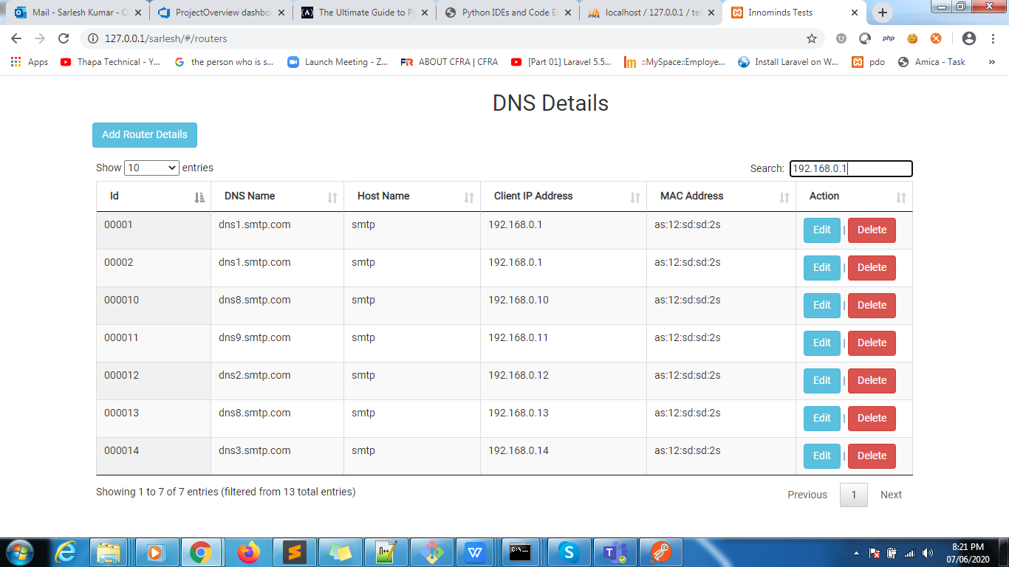

1. For edit or add form

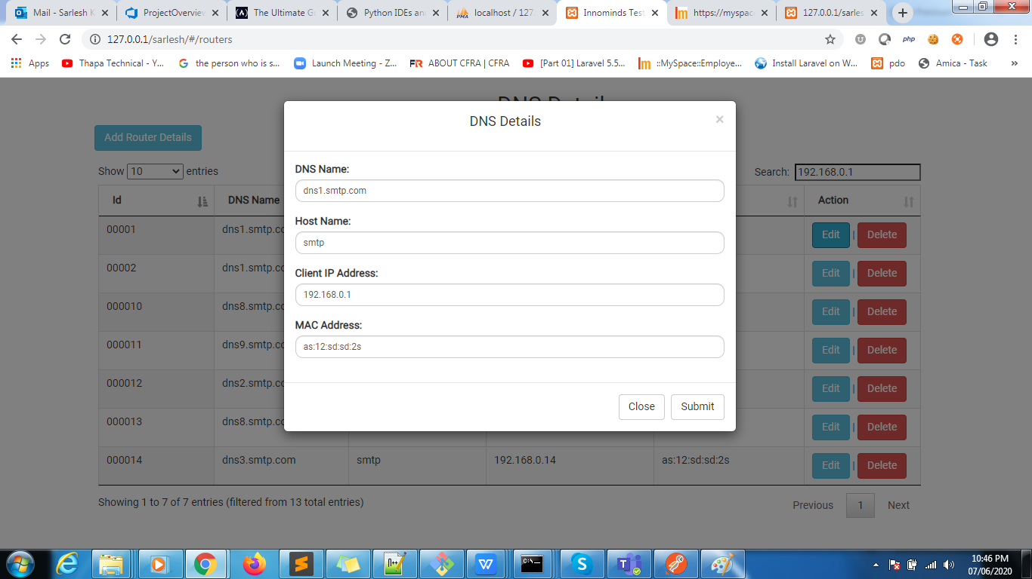

3-Success message

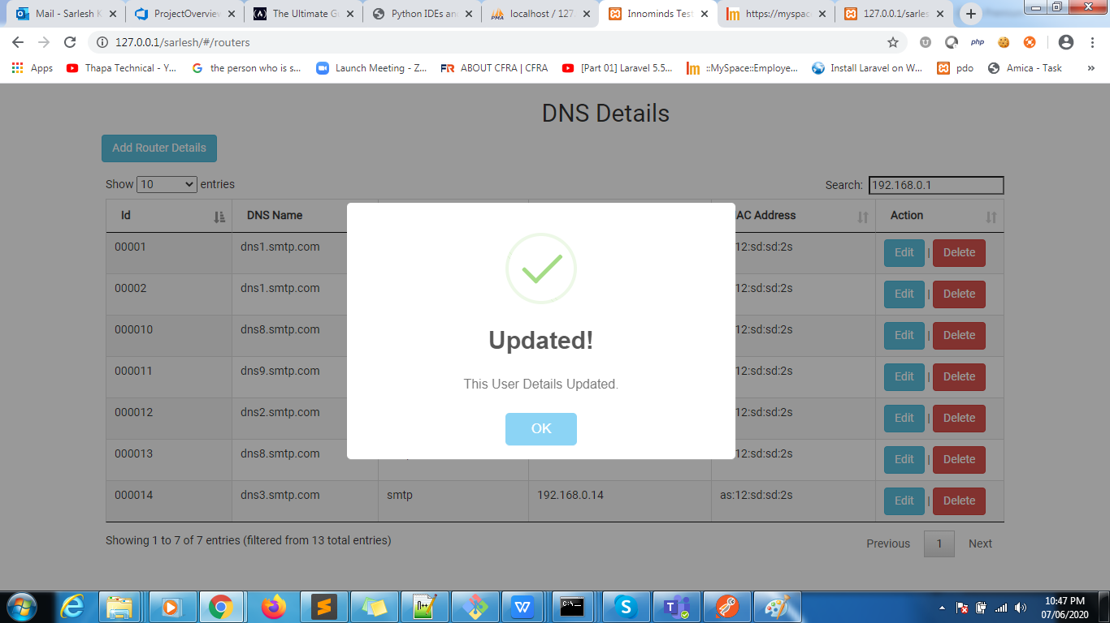

1. Soft delete confirmation

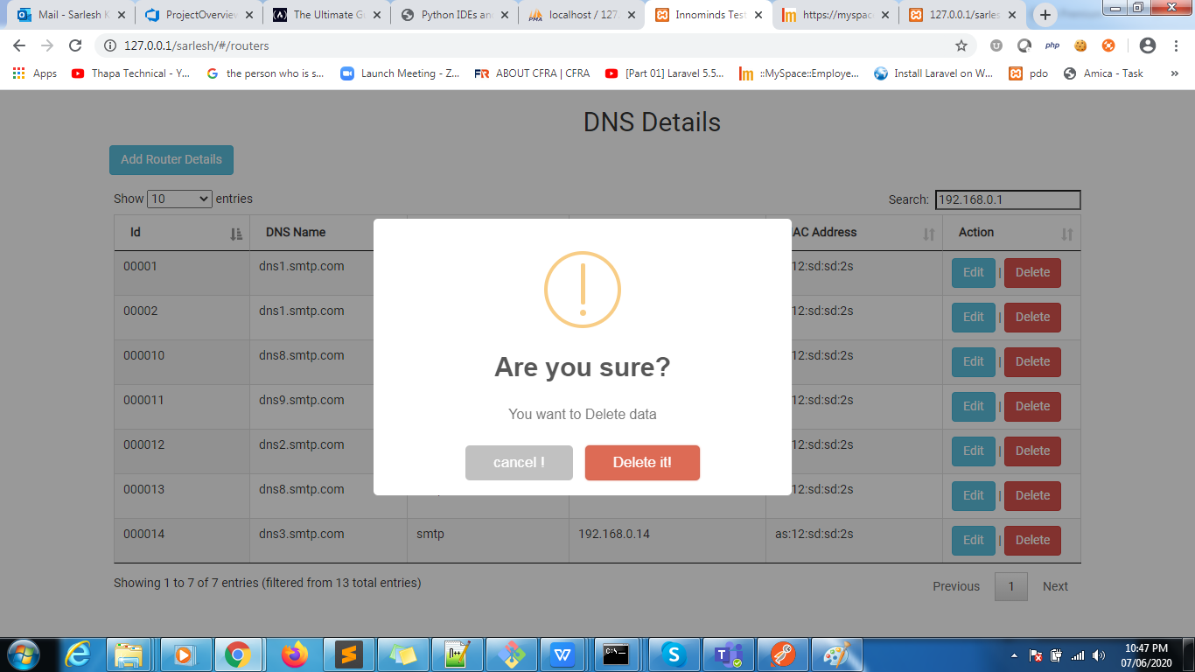

=================================end First task=====================================

1. **write a script to generate the sample data to create the unique id of 20 records and which will be executed on command prompt.**

**Answer:- for this task written code in uniqueid.php file .**

**URL- To check output , Open CMD “command prompt” then go your server root directory of project ex- C:\xampp\htdocs\sarlesh> then write command “php uniqueid.php ”**

**Output-**

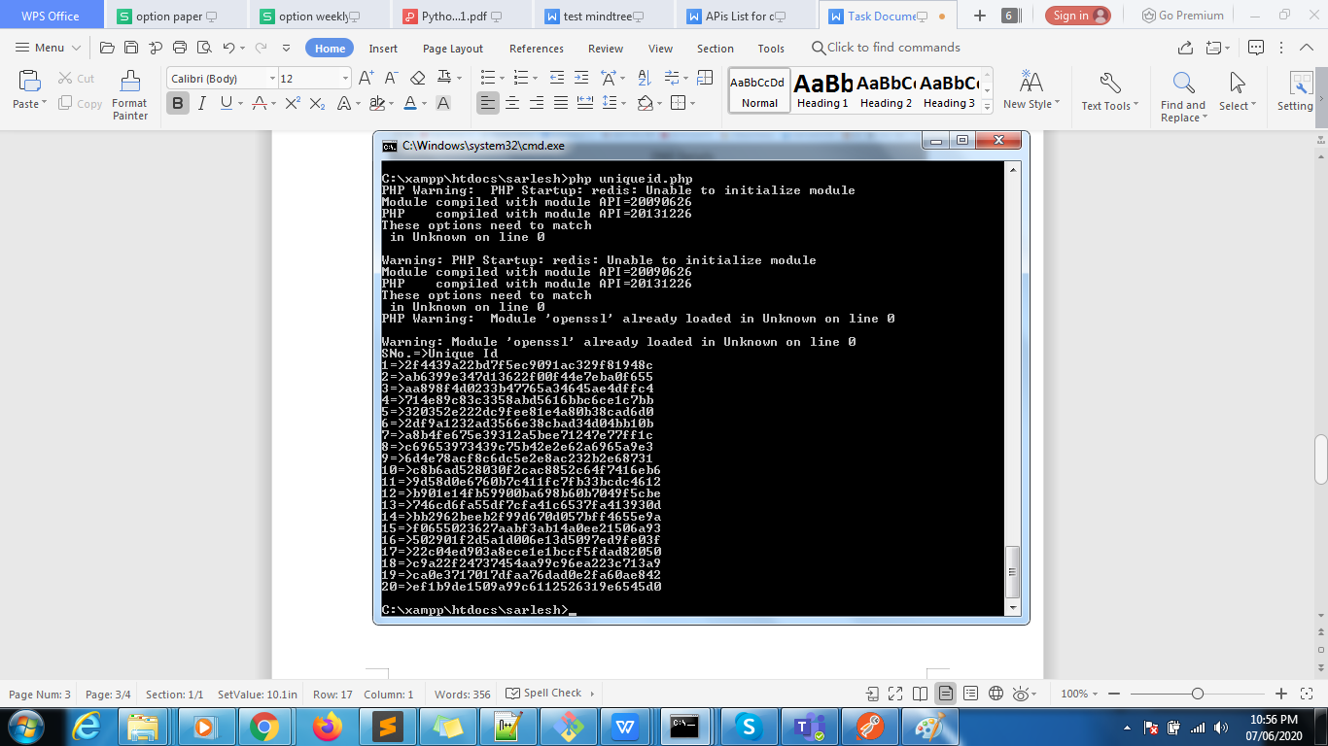

**=============================Ans 2 ended ============================**

1. **write a program to draw geometric figures such as below using any given coordinator.**



**Answer:-I have develop this task two ways , one is static , and one is dynamic**

**Url 1-** <http://127.0.0.1/sarlesh/draw_normal.html> (static)

**Url 2-** <http://127.0.0.1/sarlesh/draw.php> (Dynamic)

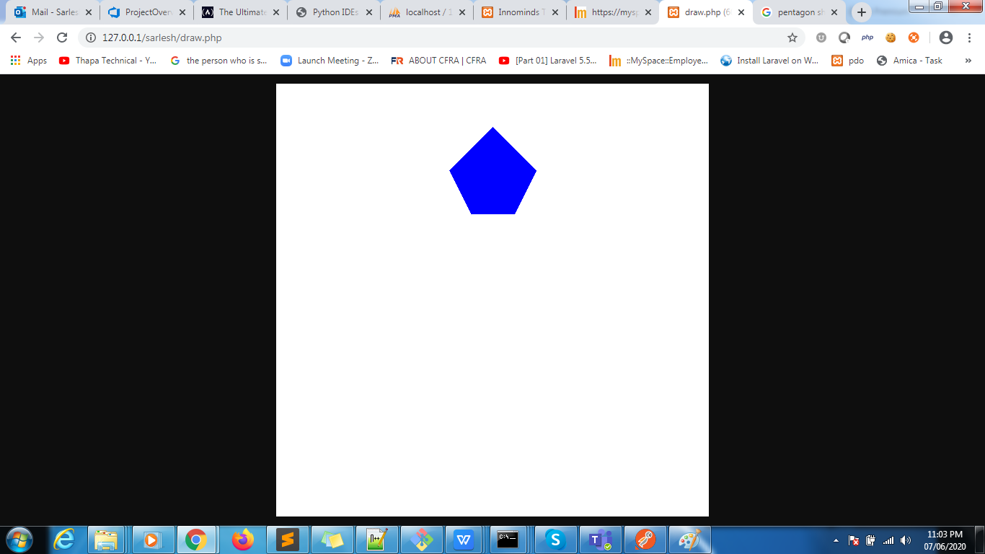

1. **create an authenticated user access REST Api**

**Answer:- I Created all APIs with “basic Auth”**

**Username- admin**

**Password- 1234**

**[{"key":"Authorization","value":"Basic YWRtaW46MTIzNA=="}]**

**Authentication api - [http://](http://127.0.0.1/sarlesh/login)**[127.0.0.1/sarlesh/login](http://127.0.0.1/sarlesh/login)

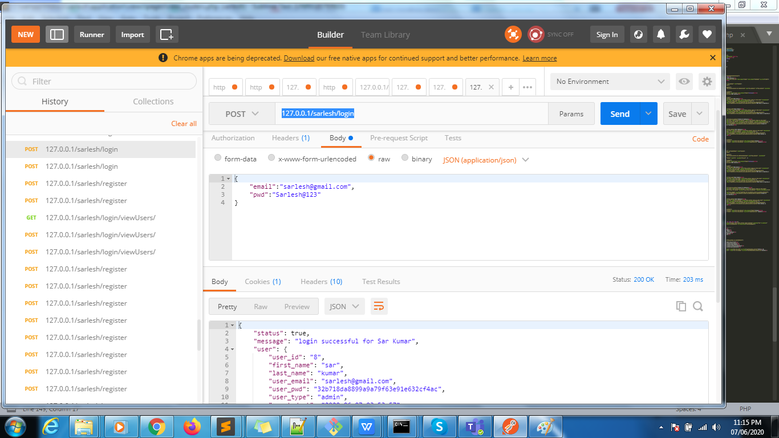

**5- create a REST API services for below actions**

**a- GET**

**b- POST**

**c- PUT**

**d- DELETE**

**Answer:-All apis I have written in separate file . when we can seen all input param and output JSON Object**

**Path - Inside my folder- sarlesh/ api_list.doc**

**1- http://127.0.0.1/sarlesh/register (POST Method)**

**2- http://127.0.0.1/sarlesh/login (POST Method)**

**3- http://127.0.0.1/sarlesh/login/viewUsers/ (GET Method)**

**4-http://127.0.0.1/sarlesh/dashboard/changestatus/9 (POST method)**

**5-http://127.0.0.1/sarlesh/dlogin/userdetails (GET method)**

**6-http://127.0.0.1/sarlesh/login/logout (GET method)**

**7-http://127.0.0.1/sarlesh/dashboard/getuserdetails/9 (GET method)**

**9-http://127.0.0.1/sarlesh/dashboard/deleteuser/9 (DELETE method)**

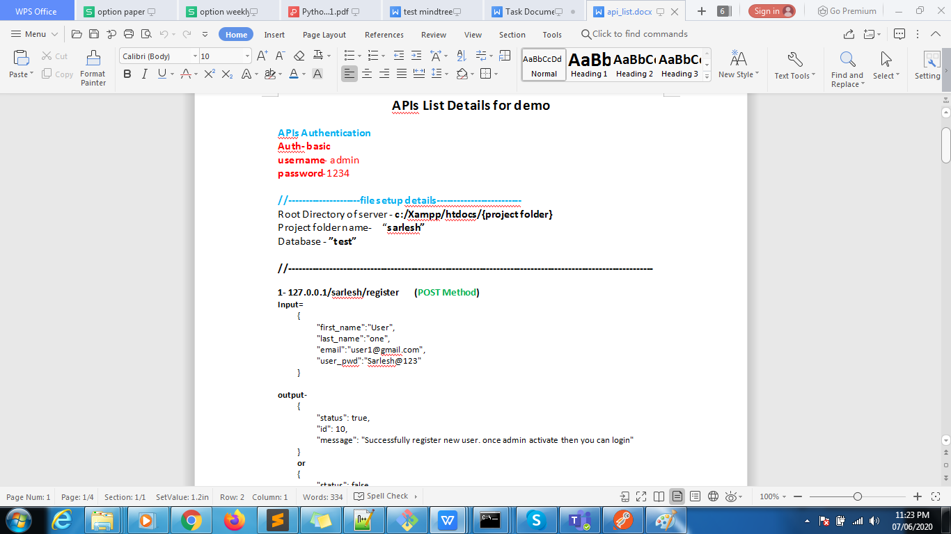

**6- Telnet to the server , create number of files and zip all files and then download the file and extract the files.(unable to understand)**

**I have created all task in zip and sending you**

**For any query or if code is not running properly then you can ping me**

**Communication details -**

**ph. No - 8960756038 / 8019129443**

**Email- sarleshjaiswal@gmail.com**